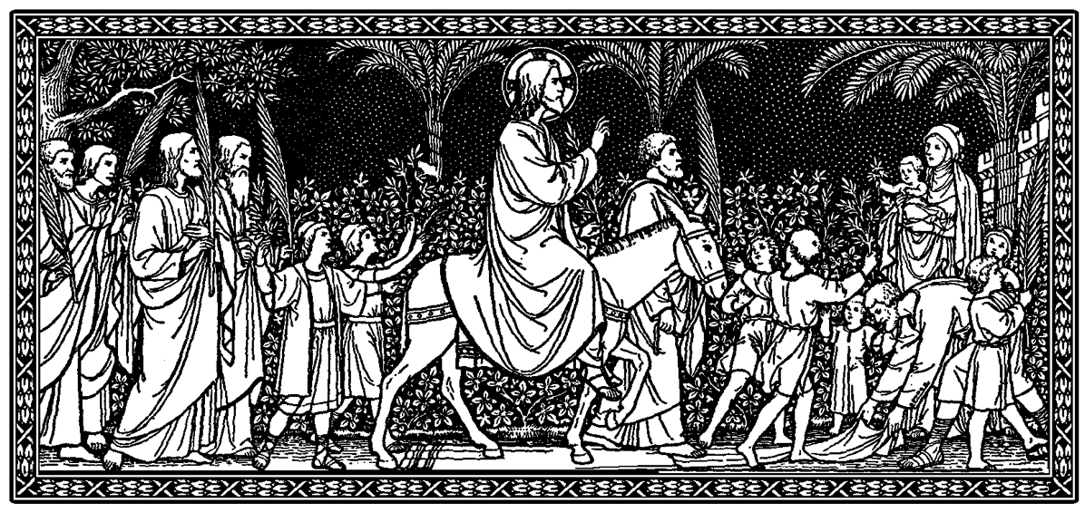

Procession Gospel: Luke 19:28-40
1st Reading: Isaiah 50:4-7
Responsorial: Psalm 22
2nd Reading: Philippians 2:6-11
Gospel: Luke 22:14-23:56

“Dearly beloved, our life should be such a procession. Our ordinary, everyday life, I mean. What does it matter that instead of palms, we hold brooms and tools of all kinds, dishes and scrubbing brushes and books. Every day of our life should be a living Hosanna to Christ the King, a march, a triumphal march toward Jerusalem, the City of God – and the day of his Second Coming, the Parousia… But we also remember, as we walk daily in this glorious procession of love and allegiance, that it will lead us inevitably to Golgotha. About that we should be joyful, as we grow in love and faith. For as we grow, an incredible miracle will take place within us by the grace of God: Golgotha, the cross, the tomb will become so very small and easy of acceptance, even willed, desired and waited for. Our growing faith and love will center on the Resurrection and on the Ascension that guarantees us our heart’s desire: oneness with the Beloved” (Catherine Doherty, Seasons of Mercy, 70-1).

