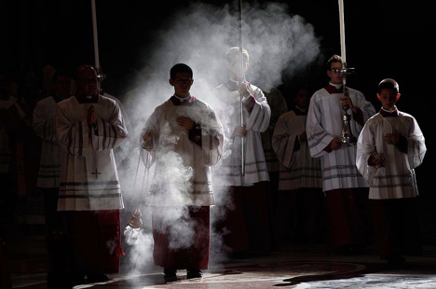

Manual of Prayers

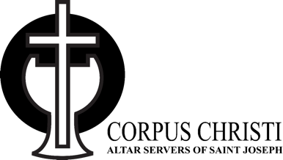
Altar Server Edition

Approved for use by Fr. Bruce-John Hamilton
Table of Contents

How to Use This Book… 3
Why Pray… 4
How to Deal with Distractions… 5
2 Different Ways to Pray… 6
4 Different Kinds of Prayer: “ACTS” … 7
7 Tips to Pray Better… 8
Morning Prayer… 9-10
Morning Thoughts… 11-12
Prayers throughout the day… 13-15
Prayers before Mass… 16-17
Thoughts before Mass… 18-19
Prayers after Mass… 20-23
Thoughts after Mass… 24
Visits to Blessed Sacrament… 25-27
Thoughts on Rosary… 28
Chaplet of Divine Mercy… 29
Examination of Conscience to prepare for Confession… 30-31
Inspirational Quotes about Confession… 32
Altar Serving… 34-37
Priesthood… 38
Night Prayers… 39-40

How to Use This Book
1. Read through the different prayers, holy thoughts, and prayer tips collected in this book. All of this will help you to become a true friend of Jesus.
2. Use these prayers at the intended times: morning, before Mass, after Mass, before you go to bed, etc. I’ve provided many different prayers to use, so don’t feel like you have to use them all. Just pick one or two that you like.
3. Memorize your favourite prayers. When you find a prayer you like, put a star beside it and try to memorize it so that you can say it without having to use the book.
4. Share your favourite prayers with friends and family.
5. Add your own favourite prayers to the book that you know. Make it your own!
6. Use this book often because it will help you become a great saint! “It is Jesus who stirs in you the desire to do something great with your lives!” – St. John Paul II

Why Pray?
1. God Himself invites us to pray.
The #1 motivation to pray should be the fact that God Himself is inviting us to do it: “God calls us to pray to Him, because right from the start, and far more than we can imagine, He ardently desires to enter into communion with us” (Fr. Jacques Philippe). The Catechism says that “God never ceases to draw man to himself” (27). Since God asks us to pray (Mt 26:41, 1 Thess 5:17, Eph 6:18), we must not pray with a utilitarian attitude (focusing on results and profits) but rather with an attitude of loving, trustful obedience that “wasting time” with God in prayer is the most important thing we can do.
2. A heart-to-heart with God.
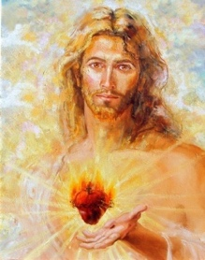
Prayer is a heart-to-heart conversation with the God who is Love (1 John 4:16). God desires to hear about everything that is happening in your life: your joys, sorrows, frustrations, difficult relationships, back pains, everything. By revealing our hearts to God, He opens His hearts to us. St. Padre Pio said: “Prayer is the best weapon we possess. It is the key that opens the heart of God.” This heart-to-heart dialogue leads us to the ultimate goal of all prayer – to fall in love with God.
3. Prayer is oxygen for the soul.
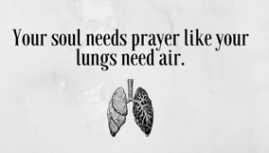
Oxygen for our lungs is like prayer for our souls. Without it, our souls die. Prayer is the “one thing necessary” Jesus spoke about in the Gospels (Luke 10:42). Pope Benedict XVI said: “If the lungs of prayer and of the Word of God do not nourish the breath of the spiritual life, we risk suffocating in the midst of a thousand daily cares. Prayer is the breath of the soul and of life.”

How to Deal with Distractions
Ever try to pray and you immediately think about your recent Fortnite battle, or what you want to eat at McDonalds for your next meal, or whether your friend is going to text you back right now? Distractions seem to arise any time we try to pray. The Catechism states this fact plainly: “The habitual difficulty in prayer is distraction” (#2729).
Fortunately for us, the saints show us how to turn distractions from burdens into blessings!
1. Don’t get frustrated. St. Francis de Sales, one of the best teachers in the Church on prayer, tells us never to get frustrated when we are distracted. He says:
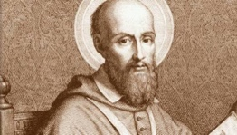
“When your mind wanders or gives way to distractions, gently recall it and place it once more close to its Divine Master. If you should do nothing else but repeat this during the whole time of prayer, your hour would be very well spent and you would perform a spiritual exercise most acceptable to God.”
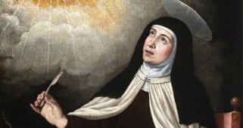
When distracted, “gently recall” your mind back to what you are praying about. Simply say to yourself, “Oh, I’m distracted.” Peacefully admit it. And go back into prayer. St. Teresa of Avila said that we should “think of distractions as mere clouds passing in the sky, momentarily taking your gaze from the Sun of Righteousness.”
2. Focus again on Jesus. St. Francis de Sales recommended that we “place it once more close to its Divine Master.” Since prayer is a heart-to-heart conversation with Jesus, we should refocus our hearts back on Jesus when we feel distracted. Recall once again that Jesus is really here with you, looking at you with love, and desiring to speak with you. Ask Jesus to teach you how to overcome distractions.
3. Trust. We need to trust that if our whole time of prayer was nothing but bringing our wandering mind back to Jesus, we had a very good time of prayer that will bear fruit in our lives: peace, love, joy, happiness, etc. Even if we have to battle 100 distractions during 15 minutes of prayer, trust that it is time well spent
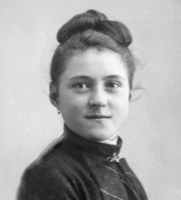
Bonus: If none of this works, heed the advice of St. Therese of Lisieux, who cleverly used her distractions to pray for whatever she was being distracted about: “I have many distractions, but as soon as I am aware of them, I pray for those people, the thought of whom is diverting my attention. In this way, they reap the benefit of my distractions.”
2 Different Ways to Pray
If you’re wondering what to do with a time of prayer, here are 2 basic ways to pray:
1. Vocal Prayer:
Vocal prayers are verbal prayers, written or spoken, formula (“Our Father”) or spontaneous (“Jesus help me”). These prayers are good because they instruct us and nourish our spiritual lives with the truth, goodness, and beauty they express.
3 Tips to Improve Vocal Prayer
- First, put yourself in God’s presence – Picture Jesus beside you, listening to you, happy to be with you, looking at you with love.
- Quality over quantity – It is much better to say fewer prayers with attention and love than many prayers with little care or in a rushing way.
- Create silence: Turn off the phone and any other sources of distractions and noise. Find a quiet place where you can be alone with Jesus.

2. Meditative Prayer:

Christian meditation is when we reflect on suitable thoughts (from the Bible or Catholic books, etc) that lead to acts of adoration, praise, petitions, thanksgiving, expressions of sorrow or love. If you feel like telling Jesus that you love Him, while reading the Bible, for example, stop reading, close your eyes, and tell Him everything that is on your heart.
2 Tips to Improve Meditative Prayer
- Be simple. Love is the goal – Simplicity is best. St. Teresa of Avila said: “The important thing is not to think much but to love much.”
- Focus on Jesus – Jesus must be the focus of your time of meditation. Talk to Him as you would your best friend.
Bonus: Vocal prayer and meditative prayer can also lead to contemplative prayer. It is a divinely given type of prayer that only God can give us. We are simply aware of God’s loving presence, we “gaze on the divine beauty” (Psalm 27:4) and are filled with His love – amazing!

4 Different Kinds of Prayer: “ACTS”
If you are not sure what to say during personal prayer time (whether it’s vocal or meditative prayer), consider these different kinds of prayer:
A. Adoration: “I love you.”
Adoration is blessing and giving honor to God, often in respectful silence. We adore God in the Blessed Sacrament, gazing upon Jesus with love. Jesus is waiting for us in the Eucharist. We can go to Him in the Eucharistic Adoration chapel at Corpus Christi or spend time with Him in the church, where He is located in the tabernacle.

C. Contrition: “I’m sorry.”
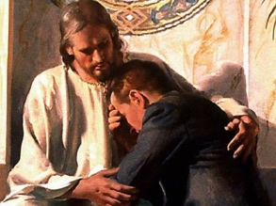
We ask God for forgiveness and mercy for the times when we have sinned. We can make an “examination of conscience”, where we go over our days in our minds and ask God to forgive us for the times we turned away from loving God and others and also go to the Sacrament of Reconciliation.

T. Praise and Thanksgiving: “Thank you.”
We praise God because He is God! “God is love” (1 John 4:16). He is all perfect, kind, good, and merciful. We praise and thank Him for everything He does for us too. This will open our hearts and bring us joy. In thanksgiving, you bless God for everything in life, the joys as well as the crosses. Praise is when you worship God not so much for what he does but because of who he is.
S. Supplication: “Please…”
In petition, you ask the Lord for whatever you need: forgiveness, courage, hope, guidance, etc. Since God is our loving Father, we ask Him with trust for the things we need. God will not always give us what we exactly ask for but He will always give us what is good for us: “And this is the confidence that we have toward him, that if we ask anything according to his will he hears us” (1 John 5:14).
7 Tips to Pray Better
1. “Just do it”. Without decisions nothing gets done. If you want to, make the decision to start praying daily and grow in your friendship with Jesus. Don’t make excuses. Decide ahead of time to pray. For example: I will pray every morning for 5 minutes using the morning prayers from this booklet before I have breakfast.
2. Be faithful in little things. Start with small steps. And be faithful to it. For example: Pray one decade of the rosary every day rather than trying to pray a whole rosary.
3. Keep a list of prayer intentions. Write down a list for yourself and others. Put this list in a place you will see it every day. Pick it up, read through the list, and ask God to answer each of these intentions according to His will.
4. Choose a variety of ways. Discover and practice the many ways of praying, which can vary depending on the time, who you are with, and how you feel. For example: Praying a rosary with family, reading the Bible on your own before breakfast, praying short prayers throughout the day (“Jesus I trust in You”), and reviewing your day with Jesus before bed. Try praying a rosary or divine mercy chaplet in the car or on the bus – it’s a great way to spend that time with Jesus!

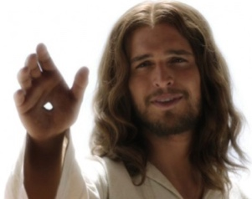
5. Say hello! “When a friend enters a room, the first thing most people do is say hello or throw up a wave or nod. In many ways, this is the beginning of prayer: an acknowledgement of God's presence. When we walk into a Church, we genuflect in front of the tabernacle to humble ourselves while we acknowledge and reverence the real presence of Jesus in the Eucharist inside. As you begin to pray, whether it's just walking somewhere during the day, in a chapel or in your room, take a moment to acknowledge whose presence you are in. 'Be still, and know that I am God' (Psalms 46:11).” – Lifeteen Blog
6. Be yourself. God desires to be in a relationship with you. He has created you with unique gifts and passions and wants you to shine in them uniquely. Come to Him as you are and let Him transform you into the saint He wants you to be!
7. Read good books. Find some inspirational books about how to pray better or the lives of the saints. We need good role models and the saints are the best role models we have – they show us Jesus is powerful ways!
Morning Prayers
To be said as early as possible upon waking up…
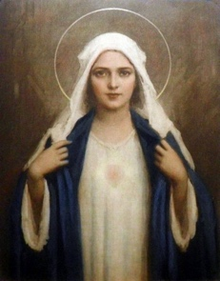
“O Jesus, through the Immaculate Heart of Mary, I offer You my prayers, works, joys and sufferings of this day for all the intentions of Your Sacred Heart, in union with the Holy Sacrifice of the Mass throughout the world, in reparation for my sins, for the intentions of all my relatives and friends, for this special intention _____, and in particular for the intentions of the Holy Father. Amen.” – Morning Offering
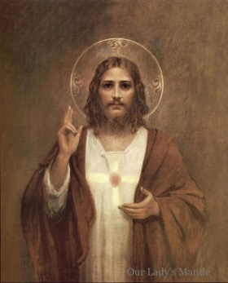
“Heavenly Father, I offer You all my actions of this day for the intentions and for the glory of the Sacred Heart of Jesus. I desire to sanctify every beat of my heart, my every thought, my simplest works, by uniting them to Its infinite merits; and I wish to make reparation for my sins by casting them into the furnace of Its Merciful Love. Heavenly Father, I ask You for myself and for those whom I hold dear, the grace to fulfill perfectly You Holy Will, to accept for love of You the joys and sorrows of this passing life, so that we may one day be united together in Heaven for all Eternity. Amen.” – St. Therese of Lisieux
“Lord, this morning, I place myself in Your Presence and ask You for peace, wisdom, and strength. Help me to be patient, understanding, and cheerful, to see others as You Yourself see them. May I be so good and joyful that all those who see me may feel Your Presence.” – Morning Petition

“Jesus, my Savior and Master, model of all perfection, I will try my best today to imitate Your example, to be like You, humble, pure and charitable. I will redouble my efforts to see Your image in all those I meet and deal with this day, and to be as helpful to them as I would be to You. I resolve to avoid this day all those sins which I have previously committed and which I now sincerely desire to give up forever. Amen.” – Morning Prayer of Resolution
“Lord, help me to live this day, quietly, easily; to lean on your great strength, trustfully, restfully; to wait for the unfolding of your will, patiently, serenely; to meet others, peacefully, joyfully; to face today, confidently, courageously.” – St. Francis of Assisi

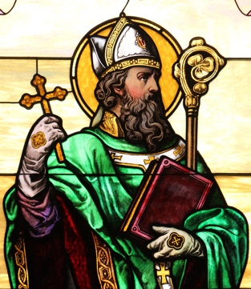
“I bind unto myself today, the power of God to hold and lead, his eye to watch, his might to stay, his ear to harken to my need; the wisdom of my God to teach, his hand to guide, his shield to ward; the word of God to give me speech, his heavenly host to be my guard… Christ be with me, Christ within me, Christ behind me, Christ before me, Christ beside me, Christ to win me, Christ to comfort me and restore me, Christ beneath me, Christ above me, Christ in quiet, Christ in danger, Christ in hearts of all that love me, Christ in mouth of friend and stranger.” – St. Patrick’s Breastplate

“My God, I give You this day. I offer You, now, all of the good that I shall do, and I promise to accept, for love of You, all of the difficulty that I shall meet. Help me to conduct myself during this day in a manner pleasing to You. Amen.” – St. Francis de Sales

Morning Thoughts
To be read in the morning or during any time throughout the day…
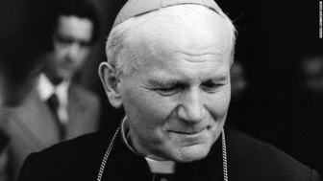
“Dear young people, the future starts today, not tomorrow… Do not be afraid. Do not be satisfied with mediocrity… We are not the sum of our weaknesses and failures; we are the sum of the Father’s love for us and our real capacity to become the image of his Son.” – St. John Paul II

“Conquer yourself each day from the very first moment, getting up on the dot, at a fixed time, without yielding a single minute to laziness. If, with God’s help, you conquer yourself, you will be well ahead for the rest of the day… Without hesitation: a supernatural reflection and… up! The heroic minute: here you have a mortification that strengthens your will and does no harm to your body. It’s so discouraging to find oneself beaten at the first skirmish.” – St. Josemaria Escriva

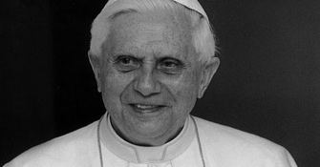
“Do not be satisfied with anything less than Truth and Love, do not be content with anything less than Christ… The world offers you comfort, but you were not made for comfort. You were made for greatness.” – Pope Benedict XVI
“Thank God ahead of time!” This was the spiritual counsel Blessed Father Solanus Casey gave to the parents of 16-month-old Elizabeth, a little girl dying of leukemia. Upon returning home, they discovered their daughter alert, healthy and full of life. You can “thank God ahead of time!” for all the blessings that will come your way today.

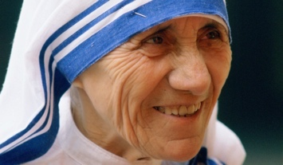
“Let us always meet each other with a smile, for a smile is the beginning of love… Spread love everywhere you go. Let no one ever come to you without leaving happier… We cannot all do great things, but we can do small things with great love. … Every work of love done with a full heart brings people closer to God.” – St. Teresa of Calcutta

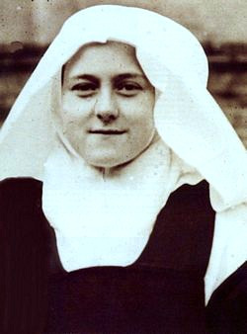
“Jesus loves a cheerful heart. He loves persons who are always smiling. Often a single word, a friendly smile, is enough to give a depressed or lonely soul fresh life.” – St. Therese of Lisieux

Challenge: The Apostolate of Smiling by Fr. Bruno Hagspiel. “Count of the number of smiles your smile has drawn smiles from others in one day. This is how many times you have promoted happiness, joy, satisfaction, encouragement, or confidence in the hearts of others. These will give birth to unselfish acts and noble deeds. The influence of your smile is spreading, though you do not always see the wonders of it working.”


“Put on the full armor of God, so that you can take your stand against the devil’s schemes.” – Ephesians 6:11

“Do not be anxious about anything, but in every situation, by prayer and petition, with thanksgiving, present your requests to God. And the peace of God, which transcends all understanding, will guard your hearts and your minds in Christ Jesus.” – Philippians 4:6-7

“Let your light shine before others, that they may see your good deeds and glorify your Father in heaven.” – Mt 5:16
Prayers during the Day
“Come, O Holy Spirit, replenish the hearts of Your faithful and kindle in them the fire of Your love. Send forth Your Spirit, and they shall be created; and You shall renew the face of the earth. Let us Pray. O God, You have taught the hearts of Your faithful by the light of the Holy Spirit. Grant that in the same Spirit we may be truly wise and ever rejoice in His consolation. Through Christ our Lord. Amen.” – Prayer to the Holy Spirit
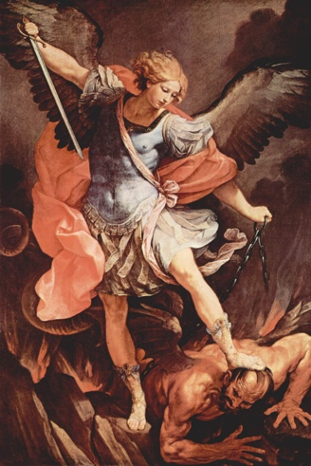
“St. Michael the Archangel, defend us in battle. Be our defense against the wickedness and snares of the Devil. May God rebuke him, we humbly pray, and do thou, O Prince of the heavenly hosts, by the power of God, thrust into hell Satan, and all the evil spirits, who prowl about the world seeking the ruin of souls. Amen.” – Prayer to St. Michael
St. Michael the Archangel is the leader of all angels (“Archangel”) and of the army of God. He has 4 main responsibilities: (1) Combat Satan; (2) Escort faithful to heaven at their hour of death; (3) Be a champion of all Christians and the Church itself; (4) Call men from life on Earth to their heavenly judgment. St. Michael is the patron of soldiers, police and doctors and is invoked for protection, especially from lethal enemies.

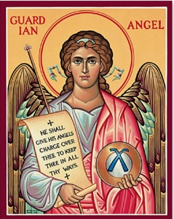
“Angel of God, my guardian dear, to whom God’s love commits me here, forever this day be at my side, to light and guard, to rule and guide.” – Angele Dei Prayer
We are each given guardian angels to help us avoid spiritual dangers and achieve salvation. We should thank God for having given us these heavenly spirits to assist us and think often throughout the day how we actually have a guardian angel watching over us – what a gift! Recite the above prayer often with faith and you will gain great courage.

“Lord Jesus Christ, take all my freedom, my memory, my understanding, and my will. All that I have and cherish you have given me. I surrender it all to be guided by your will. Your grace and your love are wealth enough for me. Give me these, Lord Jesus, and I ask for nothing more. Amen.” – Prayer of Self-Dedication to Jesus Christ

The “Pirate” Prayer: ARRR

This can be prayed at any time throughout the day or to start your private time of prayer in your room. Remember ARRR when you get stuck on how to pray.


A: Acknowledge. Acknowledge that Jesus is present with you and acknowledge how you feel right now.
R. Relate: Relate to Jesus these feelings. Share with Him why you feel that way.
R. Receive: Allow Jesus to respond to what you have told Him. Spend some time in silence. Give Him time to speak. Receive His guidance.
R. Respond: Respond to Jesus’ words or the silent movements of the heart that He stirred in you. Thank Him for this time of prayer and ask His help going forward.

Prayer of St. Richard of Chichester (adapted)

“Thank you, Jesus. My friend! My brother! Help me to know you more clearly. Help me to love you more dearly. Help me to follow you more nearly. Amen.”

Prayer to St. Anthony for Lost Items
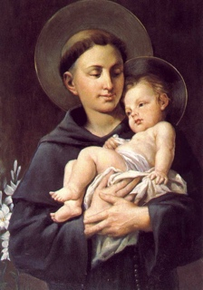
“Tony, Tony, please come down. There’s something lost that must be found!”

People pray to St. Anthony of Padua (1195-1231) to help them find what is lost. He is the patron saint of lost items. There is a famous story of him recovering a lost prayer-book during his life and many stories of St. Anthony helping others find their lost items. He is often depicted with the infant Jesus (on the left) due to a vision he received of the infant Christ during his life.

Prayer for Vocations

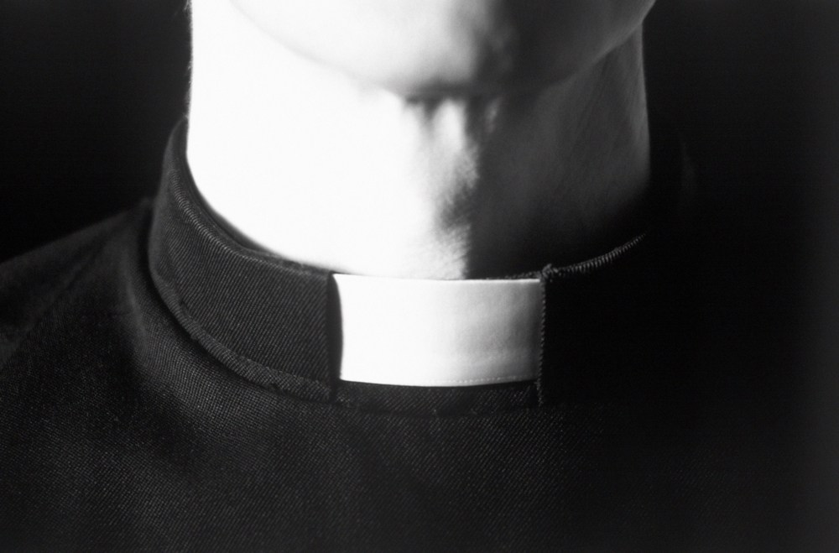“God, thank you for loving me. In Baptism you called me by name to live as your child. Help all people to know their call in life. For your greater glory, raise up generous leaders to serve you as priests, deacons, brothers, and sisters.” – Loyola Kids Book of Everyday Prayers

Peace Prayer attributed to St. Francis of Assisi
“Lord, make me an instrument of your peace:
where there is hatred, let me sow love;
where there is injury, pardon;
where there is doubt, faith;
where there is despair, hope;
where there is darkness, light;
where there is sadness, joy.
O divine Master, grant that I may not so much seek
to be consoled as to console,
to be understood as to understand,
to be loved as to love.
For it is in giving that we receive,
it is in pardoning that we are pardoned,
and it is in dying that we are born to eternal life.
Amen.”

Prayer for my Father

“Dear St. Joseph, help my dad to be a good father. Help him when he is tired, when he is worried, when he is in a hurry. Give him strength in his work and a little more time to have fun with me. Help me to show my dad how much I love him. Amen.” – Loyola Kids Book of Everyday Prayers

Prayer for my Mom

“Dear Blessed Mother Mary, help my mom to be a good mother. Give her peace and wisdom, strength and courage, grace and happiness. Be nearby when she needs help. Keep her close to your Son, Jesus. Help me always to show my mom how very much I love her. Amen.” – Loyola Kids Book of Everyday Prayers

Prayers before Mass
To be recited while preparing for the celebration of the Mass…
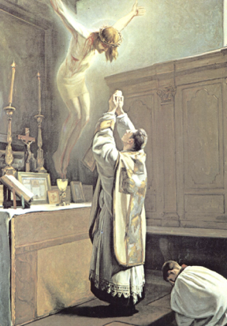
“Heavenly Father, as I prepare to assist You at Your altar, I declare my faith in You. At this Mass, keep me from distractions. Let me remember that in assisting the priest I am assisting Jesus in offering You the merits of His passion and death. I thank You for allowing me the opportunity to give my service to You. At this Mass, I join with your Priest in offering You the sacred Body and Blood of my Saviour, Jesus Christ, Your Son. May my sharing the Divine Food in Holy Communion bring me eternal salvation. Amen.” — Altar Server Prayer Before Mass

Image of Jesus’ sacrifice on the Cross being made spiritually present as the priest consecrates the bread and wine into the Body and Blood of Christ. St. Francis of Assisi said: “Man should tremble, earth should shake, all Heaven should be deeply moved when the Son of God appears on the altar in the hands of the priest.”

“O God, help me to make a good Communion. Mary, my dearest mother, pray to Jesus for me. My dear Guardian Angel, lead me to the Altar of God.” – Prayer for Help
“O God, because you have said it, I believe that I shall receive the Sacred Body of Jesus Christ to eat. My God, I believe this with all my heart.” – Act of Faith
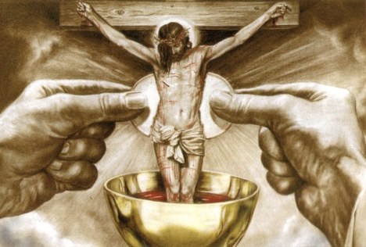
“Jesus, I love you, I desire with all my heart to receive you. Give me your whole Self, Body, Blood, Soul and Divinity, that I may live forever with you.” – Act of Love and Desire
Image of Jesus’ sacrifice on the Cross being made spiritually present during the fraction, when the priest breaks the sacred Host over the chalice.

St. Augustine said: “Recognize in this Bread what hung on the Cross, and in this Chalice what flowed from His side.”

“My Jesus, I know you are there in the Eucharist I am about to receive. You give yourself to me. I want to receive you. My soul hungers and thirsts for your love. Come and make your home in my heart. Amen.”

Thoughts before Mass
To read any time before Mass or throughout the day…
“All the good works in the world are not equal to the Holy Sacrifice of the Mass because they are the works of men; but the Mass is the work of God. Martyrdom is nothing in comparison for it is the sacrifice of man to God; but the Mass is the sacrifice of God for man.” — St. John Vianney
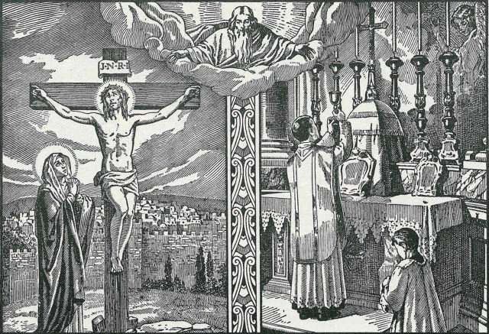
Image of the Father in heaven above looking at Jesus’ sacrifice at Calvary and the priest’s sacrifice at Mass – they are the same event. St. Thomas Aquinas said that “the Eucharist is the perfect sacrament of the Lord’s Passion inasmuch as it contains the very Christ himself who suffered.” This should fill us with wonder, awe, and gratitude for such an amazing gift!

“The Mass is the perpetuation of the Sacrifice of Calvary with the same Priest and the same Victim. The difference is that Calvary was a blood sacrifice; the Mass is offered in an unbloody manner. Furthermore, on the Cross our Lord was alone; in the Mass we are with Him.” – Venerable Fulton Sheen

“Oh, what awesome mysteries take place during Mass! A great mystery is accomplished in the Holy Mass. With what great devotion should we listen to and take part in this death of Jesus. One day we will know what God is doing for us in each Mass, and what sort of gift He is preparing in it for us. Only His divine love could permit that such a gift be provided for us.” — St. Faustina

“What miracles! Who would ever have imagined such!... If the angels could be jealous of men, they would be so for one reason: Holy Communion.” — St. Maximilian Kolbe

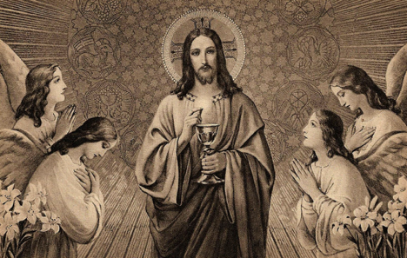
Image of Jesus as a priest holding the Eucharist with the angels adoring Him. The angels fall prostrate during the consecration at the Mass. Visualize this during Mass.

“The angels surround and help the priest when he is celebrating Mass.” – St. Augustine

“The Eucharist is the source and summit of the Christian life. The other sacraments... are bound up with the Eucharist and are oriented toward it. For in the blessed Eucharist is contained the whole spiritual good of the Church.” — Catechism of the Catholic Church # 1324

Prayers After Mass
To be said immediately after Mass concludes…

“O Lord, Jesus Christ, Eternal High Priest, I thank you for the privilege of having served at the holy altar of Your sacrifice. Now, as I put aside the garments of that service, I ask that I may at all times think of You. May I ever seek You and find You; may I always follow You; may your priestly spirit be in my heart and your Holy Name on my lips, and to Your praise and glory may every work of mine be done. Ever ready in Your service, may I always know and do Your Holy Will in all things and by Your grace persevere to the end. Amen.” — Altar Server Prayer After Mass

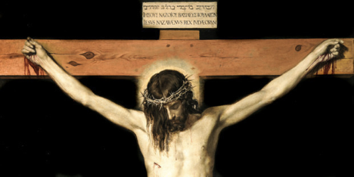
Image of Jesus dying on the Cross. When Mass is over, we should spend time thanking God for all the many blessings He has given us, recalling how He died for us on the Cross and has just given us His Body in the Eucharist: “This is love, not that we loved God, but that He loved us and sent His Son as the atoning sacrifice for our sins” (1 John 4:10).

“O Jesus, I believe that I have received you in Holy Communion, because you have said it, and your word is true. All that I have and all that I am are your gift and now you have given me yourself. Jesus, I love you with all my heart. I want to love you today more than ever.” – Act of Faith and Love

“Thank you, Jesus! You are here inside of me. Stay with me Jesus. Let your love shine within me and teach me how to love everyone I meet today. With all my heart, Jesus, I love you! You are my joy. You are my best friend.” – Act of Gratitude and Love

“Dear Jesus, help me to spread the fragrance of Your love wherever I go. Stay with me and then I shall begin to shine as You shine, so to shine as to be a light to others. The light, O Jesus, will be all from You; none of it will be mine. It will be you, shining on others through me. Let me thus praise You the way You love best, by shining on those around me. Let me preach You without preaching, not by words but by my example, by the catching force of the sympathetic influence of what I do, the evident fullness of the love my heart bears to You.” — Blessed Cardinal John Henry Newman

Image of Jesus as a priest holding the Eucharist. Jesus is showing us that He is truly present in the Blessed Sacrament and wants us to come to Him to receive Him in the Eucharist. Jesus said: “Those who eat my flesh and drink my blood abide in me, and I in them” (John 6:56).

“Mary my Mother, I consecrate to you my body which has just been honoured and sanctified by the presence of your divine Son, my soul which has conversed with Him, my heart which has loved Him. O dearest Mother, may the words which I uttered be made acceptable to Him through your intercession! and tell Him the things which I should have said but was not able to express… Receive and keep me in your heart; warn me, protect me, and guide me during this day, that I may faithfully serve your divine Son, and please Him in all my thoughts, desires, and actions. Amen.” — Consecration to Mary after Holy Communion
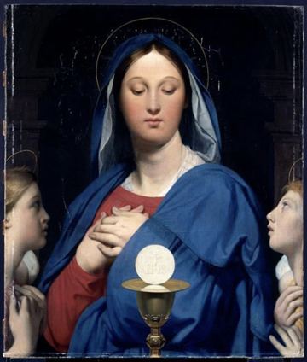
Image of Mary adoring the Eucharist, with two angels on either side looking at Mary. Mary is known as the Mother of the Eucharist. Ask Mary to teach you how to receive Jesus well in Holy Communion and to love Jesus in the best way possible every day. St. Maximilian Kolbe said: “After Holy Communion, let us pray to the Immaculate once more so that she herself may welcome Jesus in our soul and make him happy as no one ever before has been able to do.”

“Lord, Father all-powerful and ever-living God, I thank You… in the kindness of your mercy, You have fed me with the Precious Body and Blood of Your Son, our Lord Jesus Christ. I pray that this Holy Communion may be a helmet of faith and a shield of good will. May it bring me charity and patience, humility and obedience, and growth in the power to do good.” — St. Thomas Aquinas
St. Thomas Aquinas is known as the “Angelic Doctor” (that’s why he has wings in the picture above) due to his writings on the angels and his purity of heart (through which one can see God like the angels).

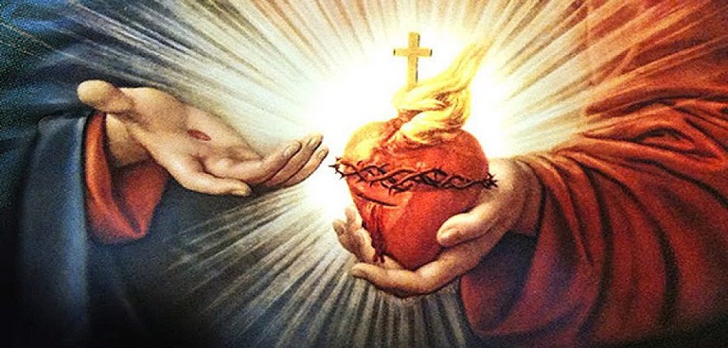
Image of Jesus holding His Sacred Heart. Jesus’ pierced heart represents His love for us. The crown of thorns represents Jesus’ Passion and victory over death. The Cross symbolizes the salvation Christ won for us. The flames of fire represent His burning love for us and purification of our sins. The light indicates that Jesus is the light of the world: “Why do we equate the Sacred Heart with the Holy Eucharist? Because the Holy Eucharist is the whole Christ with His human heart. According to St. Margaret Mary, the Sacred Heart is the Holy Eucharist. So it follows that devotion to the Sacred Heart is devotion to the Holy Eucharist. It is infinite Love Incarnate living in our midst in the Blessed Sacrament” – Fr. John Hardon

“Most Holy Trinity – Father, Son and Holy Spirit- I adore You profoundly. I offer You the most precious Body, Blood, Soul and Divinity of Jesus Christ, present in all the tabernacles of the world, in reparation for the outrages, sacrileges, and indifferences whereby He is offended. And through the infinite merits of His Most Sacred Heart and the Immaculate Heart of Mary, I beg of You the conversion of poor sinners” – Fatima Prayer (This was revealed by an angel to the three children of Fatima: Jacinta, Francisco, and Lucia (picture on right)).
Thoughts After Mass
To read after Mass or during any time of the day…

“When Mass was over I remained with Jesus in thanksgiving. Oh, how sweet was the conversation with Him that morning! It was such that, although I want to tell you all about it, I cannot... The heart of Jesus and my own — allow me to use the expression — were one. No longer were two hearts beating but only one. My own heart had disappeared, as a drop of water is lost in the ocean. Jesus was its paradise, its king. My joy was so intense and deep that I could bear it no more and tears of happiness poured down my cheeks.” — St. Padre Pio

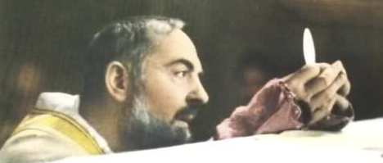
Image of Padre Pio during Mass in 1968 gazing upon Jesus with love in the Eucharist. You can tell that Padre Pio truly believes Jesus is present in the Blessed Sacrament! Padre Pio once said: “"A thousand years of enjoying human glory is not worth even an hour spent sweetly communing with Jesus in the Blessed Sacrament." Wow!

“All the good that is in me is due to Holy Communion. I owe everything to it. I feel that this holy fire has transformed me completely. Oh, how happy I am to be a dwelling place for You, O Lord! My heart is a temple in which You dwell continually.” — St. Faustina

Visits to the Blessed Sacrament
To be said as soon as you visit Jesus in the Eucharist…
“Loving Father, your beloved Son has told us, “No one can come to me unless the Father who sent me draw him” (John 6:44). Thank you Father for drawing me here to the Eucharistic Presence of Christ your Son. Thank you for allowing me to come close to the One who has come close to us in the Eucharist — who has become our companion on our way to you… May I never be without wonder before the miracle of Jesus present in the Eucharist… Please help me to offer this time of adoration with all my heart, without becoming tired or distracted. United with the Mother of God, may I ardently adore the Fruit of Mary’s womb so that my life may become fruitful in the way that best pleases you and that gives you unending glory. I ask this in the name of Jesus Christ our Lord. Amen.” — Fr. Peter John Cameron

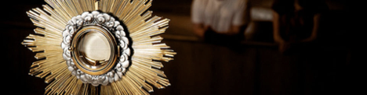

“O sacrament most holy, O sacrament divine, all praise and all thanksgiving be every moment thine!” – O Sacrament Most Holy hymn

“May the Heart of Jesus in the Most Blessed Sacrament be praised, adored and loved with grateful affection at every moment in all the tabernacles of the world unto the end of time!” – Prayer to the Blessed Sacrament
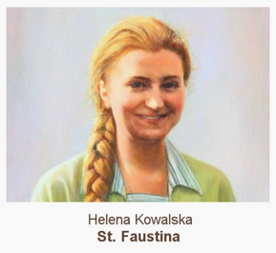
To be reflected upon during time of prayer before Jesus in the Eucharist…
“I spend every free moment at the feet of the hidden God. He is my Master; I ask Him about everything; I speak to Him about everything. Here I obtain strength and light; here I learn everything; here I am given light on how to act toward my neighbour... I have enclosed myself in the tabernacle together with Jesus.” — St. Faustina

Image of Benediction, a devotional ceremony whereby a priest blesses the people with the Eucharist being held in a monstrance at the end of a period of adoration. St. Teresa of Calcutta said: “When you look at the Crucifix, you understand how much Jesus loved you then. When you look at the Sacred Host, you understand how much Jesus loves you now.”

“The time you spend with Jesus in the Blessed Sacrament is the best time that you will spend on earth. It will make your soul everlastingly more glorious and beautiful in Heaven. A Holy Hour of adoration brings true peace to your soul and in your family. It brings us a greater love for Jesus, for each other, and for the poor.” – St. Teresa of Calcutta (image on right)

To be said throughout the day to grow in a desire to receive the Eucharist…
“My Jesus, I believe that You are present in the Most Holy Sacrament. I love You above all things, and I desire to receive You into my soul. Since I cannot at this moment receive You sacramentally, come at least spiritually into my heart. I embrace You as if You were already there and unite myself wholly to You. Never permit me to be separated from You. Amen.” — St. Alphonsus Liguori

To be said at the end of your visit to the Blessed Sacrament…
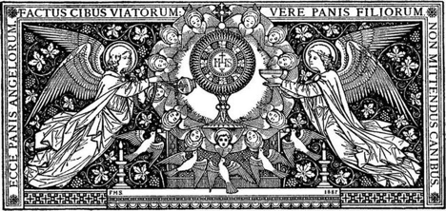
“Blessed be God. Blessed be His Holy Name. Blessed be Jesus Christ, true God and true Man. Blessed be the Name of Jesus. Blessed be His Most Sacred Heart. Blessed be His Most Precious Blood. Blessed be Jesus in the Most Holy Sacrament of the Altar. Blessed be the Holy Spirit, the Paraclete. Blessed be the great Mother of God, Mary most Holy. Blessed be her Holy and Immaculate Conception. Blessed be her Glorious Assumption. Blessed be the name of Mary, Virgin and Mother. Blessed be St. Joseph, her most chaste spouse. Blessed be God in His Angels and in His Saints. Amen.” – The Divine Praises

Thoughts on the Rosary
“Love the Madonna and pray the Rosary, for her Rosary is the weapon against the evils of the world today… Always say the Rosary. Say it well. Say it as often as you can!” – St. Padre Pio

“The Rosary is a powerful weapon to put the demons to flight and to keep oneself from sin.” – Pope Pius XI

“How beautiful is the family that recites the Rosary every evening!” – St. John Paul II

“The Most Holy Virgin in these last times in which we live has given a new efficacy to the recitation of the Rosary to such an extent that there is no problem, no matter how difficult it is, whether temporal or above all spiritual, in the personal life of each one of us, of our families…that cannot be solved by the Rosary.” – Sister Lucia dos Santos of Fatima

Image of St. Dominic receiving a rosary from Mary and the infant Christ. According to a Dominican tradition, in 1214, Dominic experienced an apparition from Mary where Mary said that the greatest weapon to reform the world is the rosary.

Chaplet of Divine Mercy
Praying the Chaplet of Divine Mercy:
1. Make the sign of the Cross 2. Optional 3 O’Clock Prayer: “You expired, Jesus, but the source of life gushed forth for souls, and the ocean of mercy opened up for the whole world. O Fount of Life, unfathomable Divine Mercy, envelop the whole world and empty Yourself out upon us. O Blood and Water, which gushed forth from the Heart of Jesus as a Fountain of Mercy for us, I trust in You!” (Repeat 3 times). 3. Our Father, Apostle’s Creed, Hail Mary. 4. Say 1: Eternal Father, I offer You the Body and Blood, Soul and Divinity of Your dearly Beloved Son, our Lord, Jesus Christ, in atonement for our sins and those of the whole word. 5. Say 10: For the sake of His sorrowful Passion, have mercy on us and on the whole word. 6. Repeat steps 4 and 5 for all 5 decades of the Rosary beads. 7. Conclude with: Holy God, Holy Mighty One, Holy Immortal One, have mercy on us and on the whole word (Repeat 3 times). 8. Optional Closing Prayer: Eternal God, in whom Mercy is endless and the treasury of compassion — inexhaustible, look kindly upon us and increase Your mercy in us, that in difficult moments we might not despair nor become despondent, but with great confidence submit ourselves to Your holy will, which is Love and Mercy itself.
9. Make the sign of the Cross
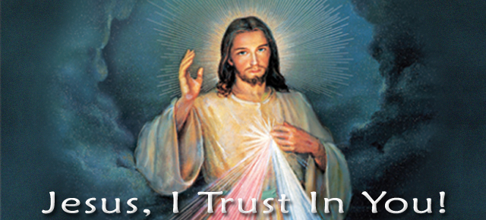

Examination of Conscience to Prepare for the Sacrament of Confession
Begin with a prayer: “Dear Holy Spirit, come into my heart and prepare my soul for this moment of grace. Grant me the gift of self-knowledge, that I may better understand the sins which keep me from You, and courage, that I may confidently confess them to Your priest. Mother Mary, please stand beside me and pray for me, that I may receive this gift of mercy from your Son. Amen.”

1. “I am the Lord your God. You shall not have strange gods before me” (Ex. 20:2-3). Have I doubted or denied the existence of God? Have I failed to love God and put Him first in my life? Do I pray every day? Have I failed to express my love for God by making time to pray every day? Have I failed to trust in God’s plan for my life? Have I engaged or believed in superstition, fortune telling, horoscopes, good-luck charms, tarot cards, palmistry, Ouija boards, etc.? Have I made a god out of money, drugs, food, alcohol, popularity, TV, girlfriend, self-image, etc? Have I ever denied being a Catholic or a truth of the Church?

2. "You shall not take the Name of the Lord your God in vain" (Ex 20:7). Have I used God’s name in vain or irreverently in any way, using His Name as a joke or as an exclamation when angry or surprised? Have I cursed or sworn? Have I failed to fulfill the promises I have made to God? Have I blasphemed God? Have I disrespected the Blessed Mother, the Church or the saints through my speech (mocking, joking, irreverence, etc.)? Have I watched movies, read books, or listened to musicians or comedians that I know slander the Lord’s name?

3. "Remember that you keep holy the Sabbath Day" (Ex 20:8). Have I intentionally missed Holy Mass on Sunday or Holy Days of Obligation? Have I deliberately come to Mass late or left early? Have I failed to avoid unnecessary work on Sunday (like extra homework or going shopping), keeping it as a day of rest, prayer, time for family and recreation? At Mass, do I pay attention to Christ and His sacrifice for me, or do I intentionally think about other things? Have I received Holy Communion under the state of mortal sin?

4. "Honor your father and your mother" (Ex 20:12). Have I disrespected or disobeyed my parents? Do I listen to my parents’ wishes the first time they ask me to do something? Have I failed to be attentive to the needs and well-being of my family? Have I been the source of anxiety or conflict in my family? Do I treat my siblings with respect and love? Have I dishonored and/or disrespected those in authority (ie teachers, coaches, officers, etc.)?

5. "You shall not kill" (Ex 20:13). Do I hold anger or hatred or grudges towards another? Do I pick on people or start fights? Have I deliberately harmed or killed another? Have I had an abortion, or encouraged someone to do so? Have I attempted suicide or seriously thought about it? Have I abused alcohol or drugs? Or taken illegal drugs? Have I been reckless in driving? Have I mutilated myself (ie. cutting)? Have I slandered another’s reputation through useless gossip or insults?

6&9. "You shall not commit adultery" (Ex 20:14) & "You shall not covet your neighbor's wife" (Ex 20:17). Have I willfully entertained impure thoughts or desires? Have I aroused my desires by impure stares or inappropriate conversation? Have I sought to read or watch something for the purposes of being aroused? Have I been impure with the use of my speech? Have I willfully viewed pornographic materials or media? Have I committed impure acts by myself (masturbation)? Have I committed impure acts with another? Have I acted impurely over the internet?

7&10. "You shall not steal" (Ex 20:15) & "You shall not covet your neighbor's goods" (Ex 20:17). Have I stolen, accepted stolen property or encouraged another to steal? Have I cheated? Have I willfully damaged or destroyed another’s property? Have I wasted time at school or work? Have I neglected to care for the poor and the Church according to my means? Have I been envious of what other people have (family, beauty, possessions, talents, career, etc.)?

8. "You shall not bear false witness against your neighbor" (Ex 20:16). Have I lied? Have I cheated on any tests or homework? Have I gossiped or revealed private information about another without good reason? Have I exposed the mistakes or sins of another without necessity? Have I told lies about another person? Have I plagiarized? Have I lied, or omitted confessing mortal sins, in the Sacrament of Reconciliation?

How to Go to Confession: ⊕ Begin by making the sign of the Cross and saying: “Bless me, father, for I have sinned. It has been N. (weeks/months/years) since my last confession and these are my sins.” ⊕ Confess your sins. When you finish confessing, end with the words: “for these and for all of my sins I am truly sorry.” ⊕ The priest will offer some advice and then assign you a penance. ⊕ You will then pray the Act of Contrition. ⊕ The priest will then say the prayer of Absolution, where the Lord frees you from sin and reconciles you with Himself and His Church.

Act of Contrition: “O my God! I am heartily sorry for having offended Thee, and I detest all my sins, because I dread the loss of heaven and the pains of hell, but most of all because they offend thee, my God, who art all-good and deserving of all my life. I firmly resolve with the help of Thy grace, to confess my sins, to do penance, and to amend my life. Amen.”

Inspirational Quotes about Confession
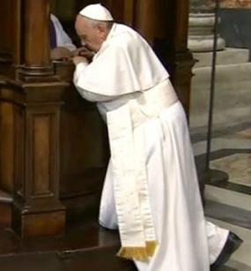
“The most important thing in the life of every man and every woman is not that they should never fall along the way. The important thing is always to get back up, not to stay on the ground licking your wounds. The Lord of mercy always forgives me; he always offers me the possibility of starting over.” – Pope Francis

“Christ Himself is waiting for you. He will heal you, and you will be at peace with God.” – St. John Paul II

“Our sins are nothing but a grain of sand alongside the great mountain of the mercy of God.” – St. John Vianney

“We come to confession to be healed; we come to be educated – like a small child, our soul has constant need of education.” – St. Faustina
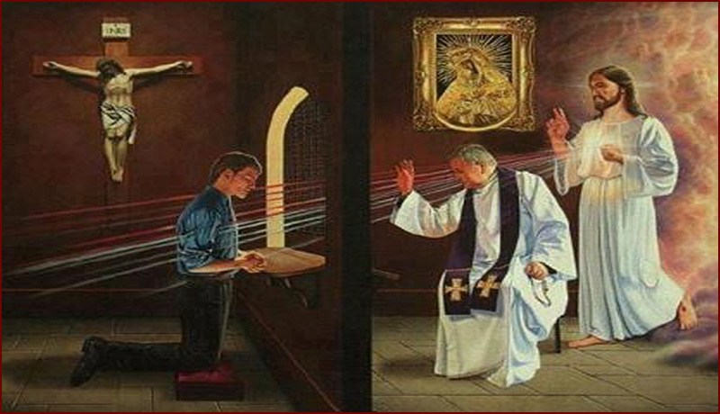
Jesus is truly there with you in the Sacrament of Confession. He is working through the priest: “When you approach the confessional, know this, that I Myself am waiting there for you. I am only hidden by the priest, but I Myself act in your soul… Never analyze what sort of a priest it is that I am making use of; open your soul in confession as you would to Me, and I will fill it with My light.” – Jesus’ words to St. Faustina

Thoughts on Altar Serving

“The altar server occupies a privileged place in the liturgical celebration. He who serves at Mass, presents himself to a community. He experiences firsthand that Jesus Christ is present and active in every liturgical act… Therefore, in the liturgy, you are much more than simple "helpers of the parish priest.” Above all, you are servers of Jesus Christ, of the eternal High Priest. Thus, you, altar servers, are called in particular to be young friends of Jesus. Be determined to go deeper and to cultivate this friendship with him. You will discover that in Jesus you have found a true friend for life… How happy I would be if something more sprang from this friendship! How beautiful it would be if some of you were to discover a vocation to the priesthood! ” — St. John Paul II

Image of St. John Paul II during World Youth Day. An event for millions of young people around the world to celebrate their Catholic faith! He said during World Youth Day: “Young people, do not be afraid to be holy!”

“Thank you for serving at the Lord’s altar and for making of this service a real school of faith and charity toward your neighbor. Thank you also for having begun to respond to the Lord, like the prophet Isaiah, ‘Here am I! Send me’ (Is 6:8).” – Pope Francis

St. Tarcisius & St. John Berchmans:
Patron Saints of Altar Serving
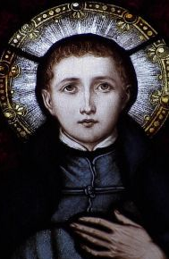
St. John Berchmans was born in Belgium in 1599. At the age of 7, he would get up at 5am and serve 2 or 3 Masses, carefully listening to the sermons.

He also had a great devotion to Mary and would often pray the Rosary. St. John always took on the most difficult chores at home.

He died at the age of 21. Many miracles were attributed to him after his death – pray to St. John!

His feast day is November 26th.

Quotes from St. John: “If I do not become a saint when I am young, I shall never become one!” “Our true worth does not consist in what human beings think of us. What we really are consists in what God knows us to be.”
St. Tarcisius was a martyr of the early church who lived in the 3rd century.

He was known to be an altar server in the early Church.

Pope Damascus composed a poem honouring St. Tarcisius, who compares him to deacon St. Stephen and says that, as Stephen was stoned by a crowd, so Tarcisius, carrying the Blessed Sacrament, was attacked by a group and beaten to death (see the story below for more details).

His feast day is August 15th.

The poem says: “When an insane gang pressed saintly Tarsicius, who was carrying the sacraments of Christ, to display them to the profane, he preferred to be killed and give up his life rather than betray to rabid dogs the heavenly Body.”

The Amazing Story of St. Tarcisius:
During the 3rd century, there was widespread persecution of the Church throughout the Roman Empire. Altar servers played an important role in secretly bringing Communion to the sick. Usually, these were strong and older men. But one day, a young altar server stepped forward and asked for the mission, saying: “Send me!” His name was Tarcisius. Although the priest was reluctant because he knew Tarcisius might be killed if he was caught, Tarcisius begged the priest, saying: “My youth will be the best shield for the Eucharist!” After making sure Tarcisius knew the importance of his task, the priest allowed Tarcisius to go.

On his way to take Communion to the sick, a group of young men saw Tarcisius and noticed that he was carefully protecting something. When Tarcisius refused to show them what he was carrying, they realized that he was a Christian, and the mob began to beat him and throw stones at him in an effort to make him drop the bag. Tarcisius died – still clutching the linen bag holding the Eucharist.
A Praetorian guard and secret Christian named Quadratus picked up the body of Tarcisius and carried him back to the priest. When Quadratus set Tarcisius’ body down, they pulled back his arms that were still clutching the linen bag, and they observed something astonishing – the Blessed Sacrament was not found. Pope Benedict XVI explains: “the consecrated Host which the little Martyr had defended with his life, had become flesh of his flesh thereby forming, together with his body, a single immaculate Host offered to God.” What a miracle!

Message from Pope Benedict XVI to Altar Servers:
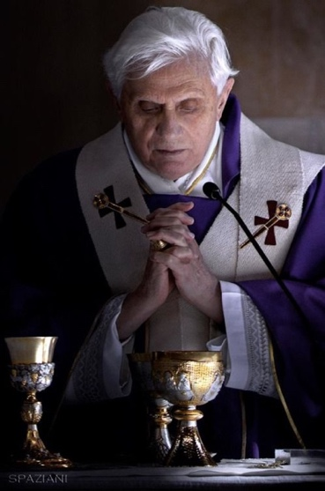
“Dear altar servers, St Tarcisius' testimony and this beautiful tradition teach us the deep love and great veneration that we must have for the Eucharist: it is a treasure of incomparable value… the Eucharist is the greatest gift that Jesus has given to us.
Serve Jesus present in the Eucharist generously. It is an important task that enables you to be particularly close to the Lord and to grow in true and profound friendship with him. Guard this friendship in your hearts jealously, like St Tarcisius, ready to commit yourselves, to fight and to give your lives so that Jesus may reach all peoples.
May you too communicate to your peers the gift of this friendship with joy, with enthusiasm, without fear, so that they may feel that you know this Mystery, that is true and that you love it!
You are lucky to be able to live this indescribable Mystery from close at hand! Do your task as altar servers with love, devotion and faithfulness; do not enter a church for the celebration with superficiality but rather, prepare yourselves inwardly for Holy Mass! Assisting your priests in service at the altar helps to make Jesus closer, so that people can understand, can realize better: he is here.
Dear friends! You lend Jesus your hands, your thoughts, your time. He will not fail to reward you, giving you true joy and enabling you to feel where the fullest happiness is. St Tarcisius has shown us that love can even bring us to give our life for an authentic good, for the true good, for the Lord.
Martyrdom will probably not be required of us, but Jesus asks of us fidelity in small things, inner recollection, inner participation, our faith and our efforts to keep this treasure present in everyday life.”
Thoughts on the Priesthood

“The priesthood is the love of the heart of Jesus. When you see a priest, think of our Lord Jesus Christ.” – St. John Vianney

“People who say that we priests are lonely are either lying or have got it all wrong. We are far less lonely than anyone else, for we can count on the constant company of the Lord, with whom we should be conversing without interruption. We are in love with Love, with the Author of Love!" – St. Josemaria Escriva
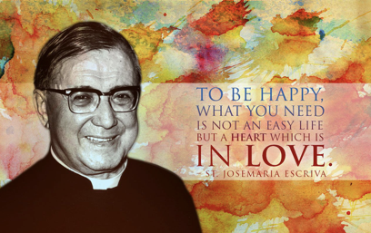

“The world looks to the priest, because it looks to Jesus! No one can see Christ; but everyone sees the priest, and through him they wish to catch a glimpse of the Lord! Immense is the grandeur and dignity of the priest!” — St. John Paul II

“Support your priests with your love and prayers, that they may always be shepherds after Christ’s heart.” – Pope Francis

Night Prayers
Matthew Kelly’s Night Prayer to be said before you go to sleep…
1. GRATITUDE: Begin by thanking God in a personal dialogue for whatever you are most grateful for today.

2. AWARENESS: Revisit the times in the past twenty-four hours when you were and were not the best-version-of-yourself. Talk to God about these situations and what you learned from them.

3. SIGNIFICANT MOMENTS: Identify something you experienced in the last twenty-four hours and explore what God might be trying to say to you through that event (or person).

4. PEACE: Ask God to forgive you for any wrong you have committed (against yourself, another person, or Him) and to fill you with a deep and abiding peace.

5. FREEDOM: Speak with God about how He is inviting you to change your life, so that you can experience the freedom to be the best-version-of-yourself.

6. OTHERS: Lift up to God anyone you feel called to pray for today, asking God to bless and guide them.

7. Pray the Our Father.

“BAKER” Examination of Conscience by Fr. Michael Gaitley:
After making the sign of the Cross and acknowledging that God is here with you…
B. Blessings. Praise and thank God for all the blessings of the day.
A. Ask. Ask the Holy Spirit to enlighten you, so you can recognize your sins.
K. Kill. It was our sins that killed and crucified Jesus. Admit our failings to Jesus.
E. Embrace. Be sorry for sin and allow Jesus to embrace you with His love.
R. Resolution. Look ahead to tomorrow. Make a decision how to act better.

Some simple night prayers to be said before you go to sleep…
“Lord, the day is ending. I offer you my day with all that was good and not so good. For all the good things I did today, I thank you. For all the bad things I did today, I ask your forgiveness. With trust, I place myself in your hands. Keep my heart in peace. Amen.” – Magnificat Prayer Book

“Jesus Christ my God, I adore you and thank you for all the graces you have given me this day. I offer you my sleep and all the moments of this night, and I ask you to keep me from sin. I put myself within your sacred side and under the mantle of our Lady. Let your holy angels stand about me and keep me in peace. And let your blessing be upon me. Amen.” – St. Alphonsus Liguori

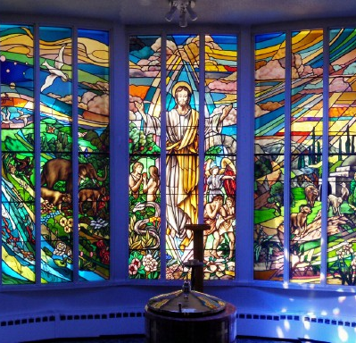
“Love to pray. Prayer enlarges the heart until it is capable of containing God’s gift of Himself.” – St. Teresa of Calcutta

