“A successful business is either loved or needed.” – Ted Leonsis, Washington Capitals Owner

Fidelity vs. Convenience: Is our product on a clear path toward either convenience or fidelity?
Fidelity is the total experience of something, rather than the cost. Aura: Sometimes based entirely on perceptions and marketing—a kind of perceived fidelity. When a product or service relies on aura alone, can lead to future issues. Identity: many of our consumer choices are a way to tell other people something about ourselves. This is particularly true when making high-fidelity choices. Identity is a reason consumers will spend money on live music, but not on recorded music. Experience + aura + identity = fidelity. Fidelity is loved.
Convenience is how easily available it is to get what you want. Another critical and perhaps counterintuitive factor to convenience is cost. It is about habit. WalMart, McDonalds, ATMs. High convenience means attracting mass markets, selling on a big scale. It is hard to get into super convenience from the start, WebVan tried to do it and customers did not respond very well. Convenience is needed.
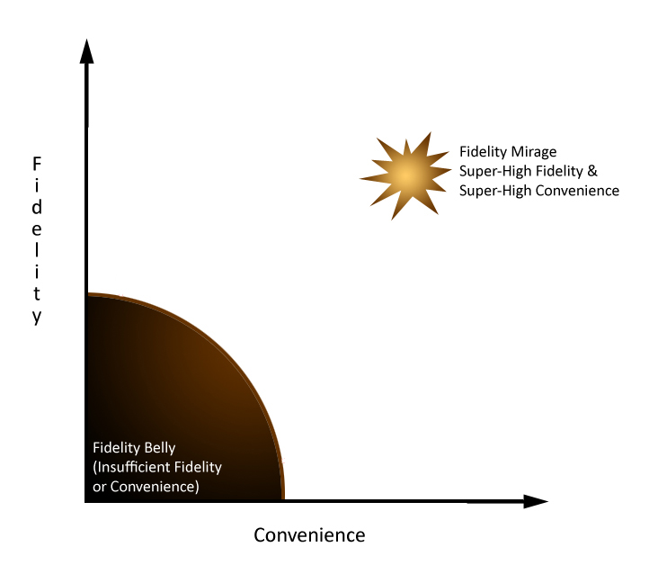
The Fidelity Belly: any product/service that is neither extremely high-fidelity nor high-convenience risks sinking into what I call the fidelity belly—the no-man’s-land of consumer experience. Most of the new products/services start off inside the fidelity belly.
Fidelity Mirage: Why not strive to make something that is both loved and needed? That tempting combo is a mirage. High fidelity is about aura and identity. Convenience acts like antimatter to aura and identity. Wrecking ball moments: every once in a while a new product or service smashes a market sector and starts an entirely new one, resetting the trade-offs people will make between fidelity and convenience. Super Fidelity or Super Convenience: this defines the winners.

Apple: has a portfolio of both high-convenience and high-fidelity products. Steve Jobs brought Apple back into high fidelity, every product had to be a wonderful experience, giving owners a sense of identity basing off its “Think Different” campaign. Apples iPhone may be the undoing of Apple if it followed Starbuck’s path. Apple always had aura and identity. Apple’s products became desired by the masses. Apple began to cut prices and ramped up production. Ipod became a habit eventually. Ipod stopped making you look cool, but rather fit in, more needed than loved. Apple began to drift away from its “Think Different” slogan. Then the iPhone was introduced to bring back Apples aura and identity. Apple can’t achieve both convenience and fidelity with the iPhone. The author, Maney, thinks Apple should put the brakes on the iPhone distribution, pump $ into R&D so they always have the highest-fidelity mobile gadget, keep prices high, maintaining aura and identity—this is closer to Apples core.
Starbucks: chased the fidelity mirage. Howard Schultz wanted to make Starbucks into a great experience, not just a great retail store. Starbucks had a special aura. Schultz took full advantage of the love shown to Starbucks and launched aggressive expansion plans...leading to the very thing that can kill a high-fidelity brand: familiarity. “Once Starbucks became ordinary, it committed suicide.” Starbucks went from high-fidelity to their expansion plans causing high-convenience. They believed starbucks could be both at the same time. Starbucks wanted to be loved and needed, which is almost impossible. The more convenient something is, the more its aura dissipates. Starbucks had a convenience issue: lines. Cool people began to find Starbucks uncool and went looking for something new—people wanted to go back & feel at home with coffee—going to boutique stores. Schultz came back into the company to help Starbucks regain its aura, closing some stores, helping employees learn how to make proper coffee (focusing on quality).
Coors-Light “cold-activated” label. Tried to add a little fidelity.
iRobot: People don’t buy a quarter-inch drill—they buy a quarter-inch hole. The drill happens to be the best means to an end, but if there were a better means, people would buy it. The iRobot was a leap in convenience. Similar fidelity, but the iRobot did the work for you. Matching products on fidelity and cost, then using robotics to gain upper hand in convenience.
The Hedgehog Concept: great companies figure out what they can do better than anyone else in the world, and then relentlessly focus on that. This concept applies to the individual too. Be the high fidelity player. 2 ways to get to the top, one is to climb an existing ladder, which can be a bit crowded and the other is to make your own ladder. Figure out what you can be best at and create a category that fits. Find your own Hedgehog Concept and stick with it. The most successful people snag a high-fidelity position on some fidelity/convenience trade-off. The higher the fidelity, the more you’ll be in demand and the more you can charge for your work—and the less you’ll have to be convenient. You have constructed a path that meets 3 tests:
1. passion (you adhere to your core values and do what you love to do)
2. genetic encoding (you do what you are genetically encoded for, activities you are made to do exceptionally well)
3. valuable contribution (you engage in work that makes a contribution of economic and social value, that gives you an economic engine for life).

“The mass of men lead lives of quiet desperation.” – Henry David Thoreau.
This is because so many people toil in careers that land inside the fidelity belly. When you have a clear sense of what distinguishes you from those around you, that sense of quiet desperation disappears.

Make Choices: The most successful people have the courage to make rigorous choices (discipline), they don’t delude themselves into thinking they can do everything, so they focus on only what they can do with great distinction. They adhere fanatically to a set of core values. They pay tremendous attention not just to what to do, but equally to what not to do. Most people settle for a good life rather than a great life, because they fail to make the disciplined decisions.

Remember: There are always going to be problems, no system is foolproof. The fidelity swap can help spot a problem waiting to happen.
- Don’t forget the tech effect. The outer borders of fidelity and convenience constantly move outward, driven by evolving technology. Constantly improve or else you will get left behind. This is why time-to-market is so crucial.
- Success is not about whether a product is cool or hip—its about where the product falls amid fidelity/convenience trade-offs. The key is whether it beats competitors on convenience or fidelity, not in absolute terms but relative to competitors.
- Different sets of consumers make different fidelity/convenience trade-offs. Different generations have different opinions on what is convenient or fidelity. Never evaluate a product or service based on enthusiasm of early adopters.
- Starting small gives a product or service agility, so it can adjust in response to the tech effect and competitors. Projects that start huge/take lots of time (teledesic, webvan) have a difficult time adjusting to changing conditions or technology & high risk.
- New technologies almost always start out inside the fidelity belly. The ones that make it out clearly aim at high fidelity or high convenience. Aiming at both is a bad idea.
- The tradeoff between fidelity and convenience is the engine of the fidelity swap.
- Looking forward: Early disasters aren’t necessarily disasters forever and early victories don’t guarantee long-term success. You have to plan out a vision for the future and base your fidelity/convenience chart on that prediction to keep up with innovation and technology.

